**SCHOOL OF DIGITAL MEDIA AND INFOCOMM TECHNOLOGY (DMIT)**

|  |  |
| --- | --- |
| **Date of Submission:** | 20 August 2018 |

|  |  |
| --- | --- |
| **Prepared for:** | Ms Lin |

|  |  |
| --- | --- |
| **Class:** | DISM 3A/02 |

|  |  |
| --- | --- |
| **Submitted by:** |  |

|  |  |
| --- | --- |
| **Student ID** | **Name** |
| 1625231 | Tan Ru Bin |
| 1625343 | Chen Yan Jiun |
| 1625819 | Kennard Chua |

**IOT CA2**

**Step-by-step Tutorial**

**DIPLOMA IN BUSINESS INFORMATION TECHNOLOGY**

**DIPLOMA IN INFORMATION TECHNOLOGY**

**DIPLOMA IN INFOCOMM SECURITY MANAGEMENT**

**ST0324 Internet of Things (IOT)**

**2017/2018 Semester 1**

**Table of Contents**

[Section 1 Overview of project 3](#_Toc522481442)

[A. Where we have uploaded our tutorial 3](#_Toc522481443)

[B. Why have we chosen to upload to this site 3](#_Toc522481444)

[C. What have we uploaded 3](#_Toc522481445)

[D. What is the application about? 3](#_Toc522481446)

[E. Summary of the steps that will be described 4](#_Toc522481447)

[F. How does the final RPI set-up looks like? 4](#_Toc522481448)

[G. How does the web or mobile application look like? 6](#_Toc522481449)

[Section 2 Hardware requirements 10](#_Toc522481450)

[Hardware checklist 10](#_Toc522481451)

[LED 10](#_Toc522481452)

[Resistor for LED 10](#_Toc522481453)

[PIR Motion Sensor 11](#_Toc522481454)

[Buzzer 11](#_Toc522481455)

[DHT11 Temperature and Humidity Sensor 12](#_Toc522481456)

[10k Ω Resistor for DHT11 sensor 12](#_Toc522481457)

[Section 3 Create IBM Iot App 13](#_Toc522481458)

[A. Setup Cloud Foundary and Bluemix IoT Service 13](#_Toc522481459)

[B. Create toolchain 17](#_Toc522481460)

[Section 4 Node-Red Bluemix 21](#_Toc522481461)

[A. Setup Node Red in IBM 21](#_Toc522481462)

[B. Adding additional Nodes for IBM 22](#_Toc522481463)

[C. Create flow in IBM Node Red 24](#_Toc522481464)

[D. Configurating Twilio Node in IBM 26](#_Toc522481465)

[Section 5 Raspberry Pi Node-Red 30](#_Toc522481466)

[A. Adding additional Nodes for in Raspberry Pi 30](#_Toc522481467)

[B. Created Node Red flow in Raspberry Pi 31](#_Toc522481468)

[Section 6 Cloudant Database 33](#_Toc522481469)

[A. Start up Historical Data Storage 33](#_Toc522481470)

[B. Data Visualization with Stored Data 36](#_Toc522481471)

[Section 7 Task Allocation 41](#_Toc522481472)

[Individual tasks 41](#_Toc522481473)

# Section 1 Overview of project

* 1. Where we have uploaded our tutorial

https://github.com/rub1nt/SLEEPDEEP

* 1. Why have we chosen to upload to this site

GitHub is a development platform built for developers ranging from open source to business. Any user can easily host and review the codes. It helps that it is easy to learn and manage. Changes made to the git project can immediately be updated after a commit, this allow users to sync their codes before they start working on it. There are also several tutorials on the web if we were to face any problems managing in github.

* 1. What have we uploaded

Codes for the nodes of ibm bluemix and raspberrypi node red along wth a step by step guide on how to setup the system to achieve the same result as our system.

* 1. What is the application about?

The application is a sleep pattern monitoring device that aims to help people or parents to learn and observe the sleeping patterns of they themselves or their child based on the motion and temperature chart. When temperature falls or rises to uncomforatble levels for the child or their room, a message will be sent to their phone to alert them. Parents are also able to control the night light in the baby’s or their room remotely from the website which is accesible by the phone as well.

* 1. Summary of the steps that will be described

|  |  |  |
| --- | --- | --- |
|  | Section | Description |
|  | Overview | Get an overview of what this project is about and where the source codes can be found |
|  |  |  |
| Sections 2 to 7 provides the step-by-step instructions to set up the application | | |
|  | Hardware requirements | Provides overview of hardware required |
|  | Create IBM IoT App | Creation of app in IBM to start bluemix IoT serivce |
|  | Node-Red Bluemix | Setup Node Red in IBM and putting the flows in to send and retrieve data from bluemix |
|  | Raspberry Pi Node-Red | Setup Node Red in Raspberry Pi and putting the flows in to send and retrieve data to bluemix |
|  | Cloudant Database | Setup of cloud database for historical data of temperature and motion graph values. |
|  | Task Allocation | Lists down the task each individual have done. |

* 1. How does the final RPI set-up looks like?

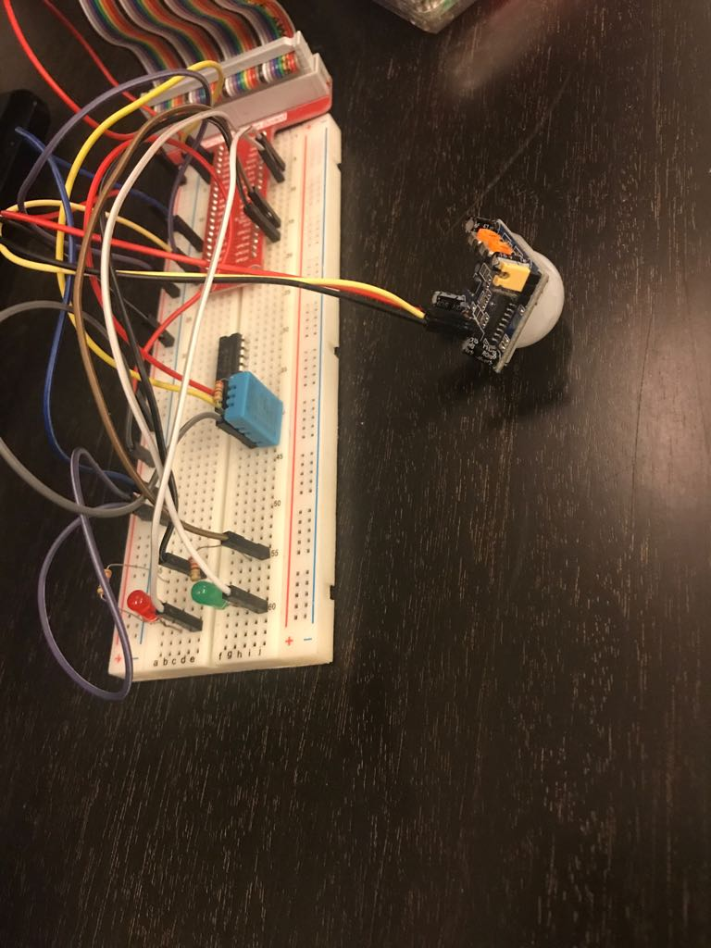

* 1. How does the web or mobile application look like?

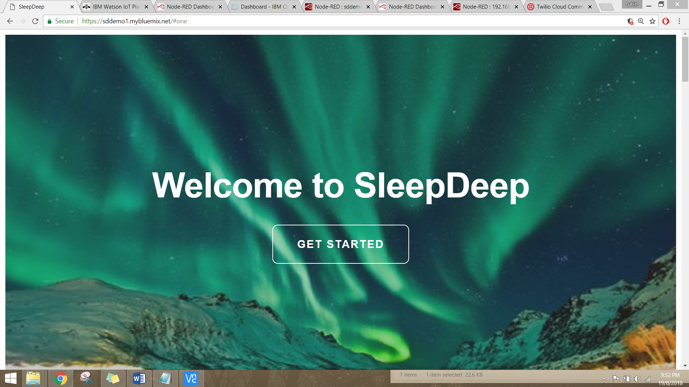

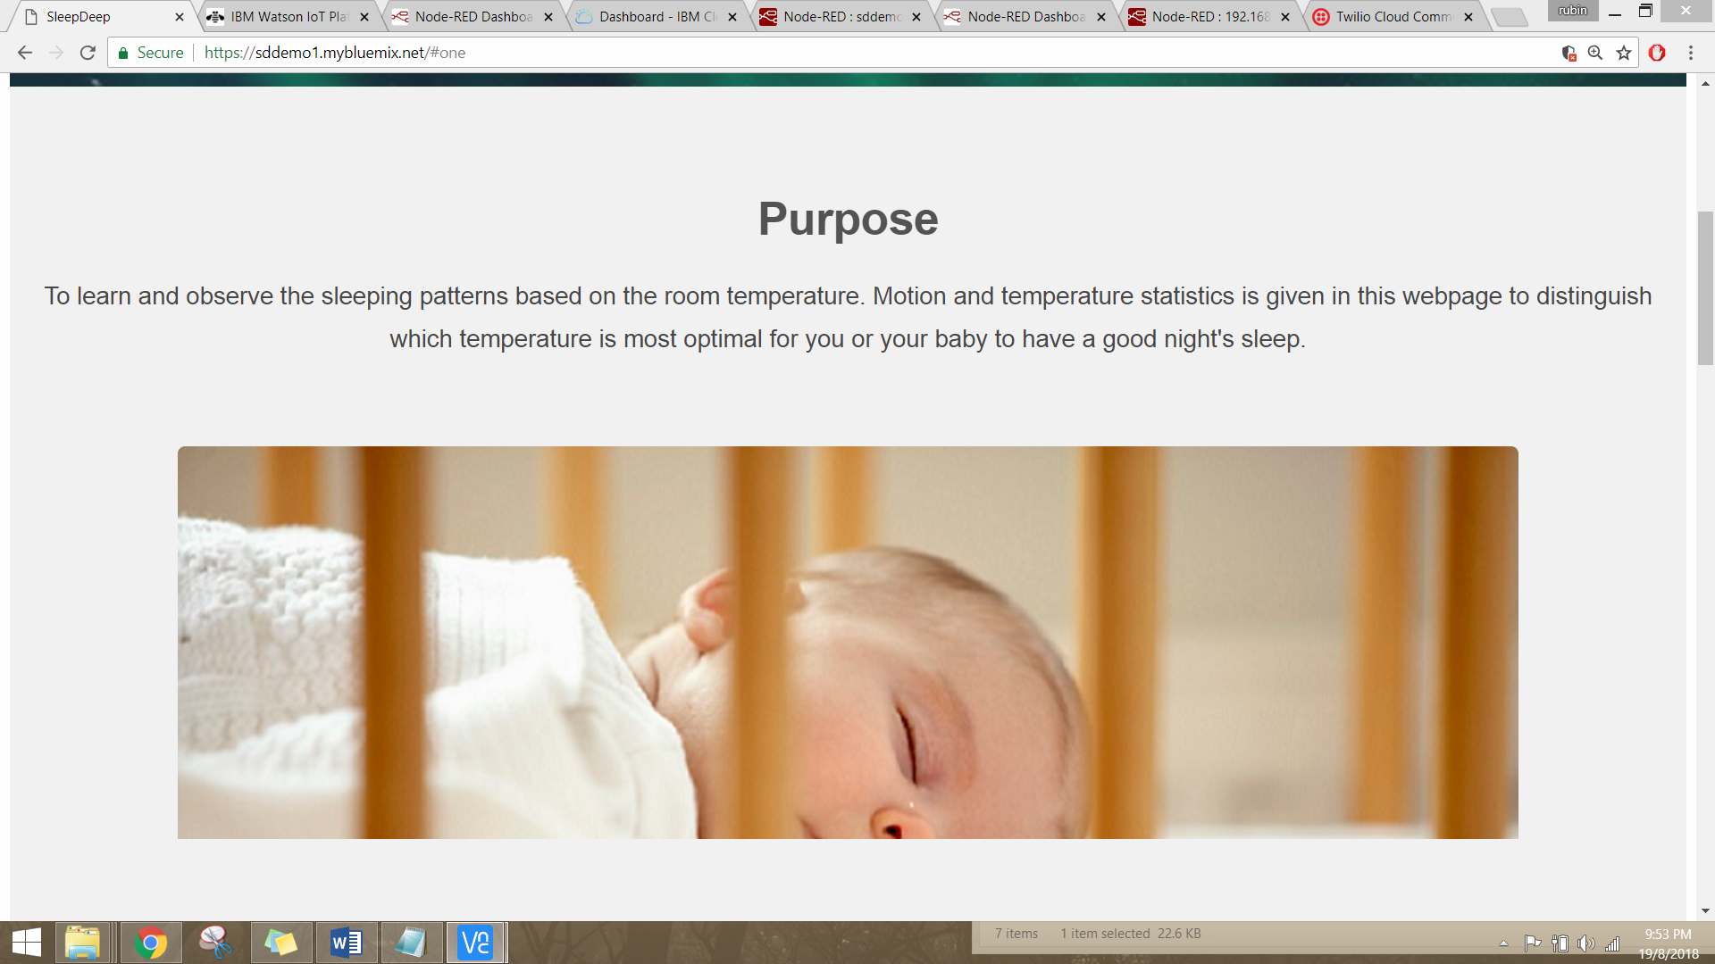

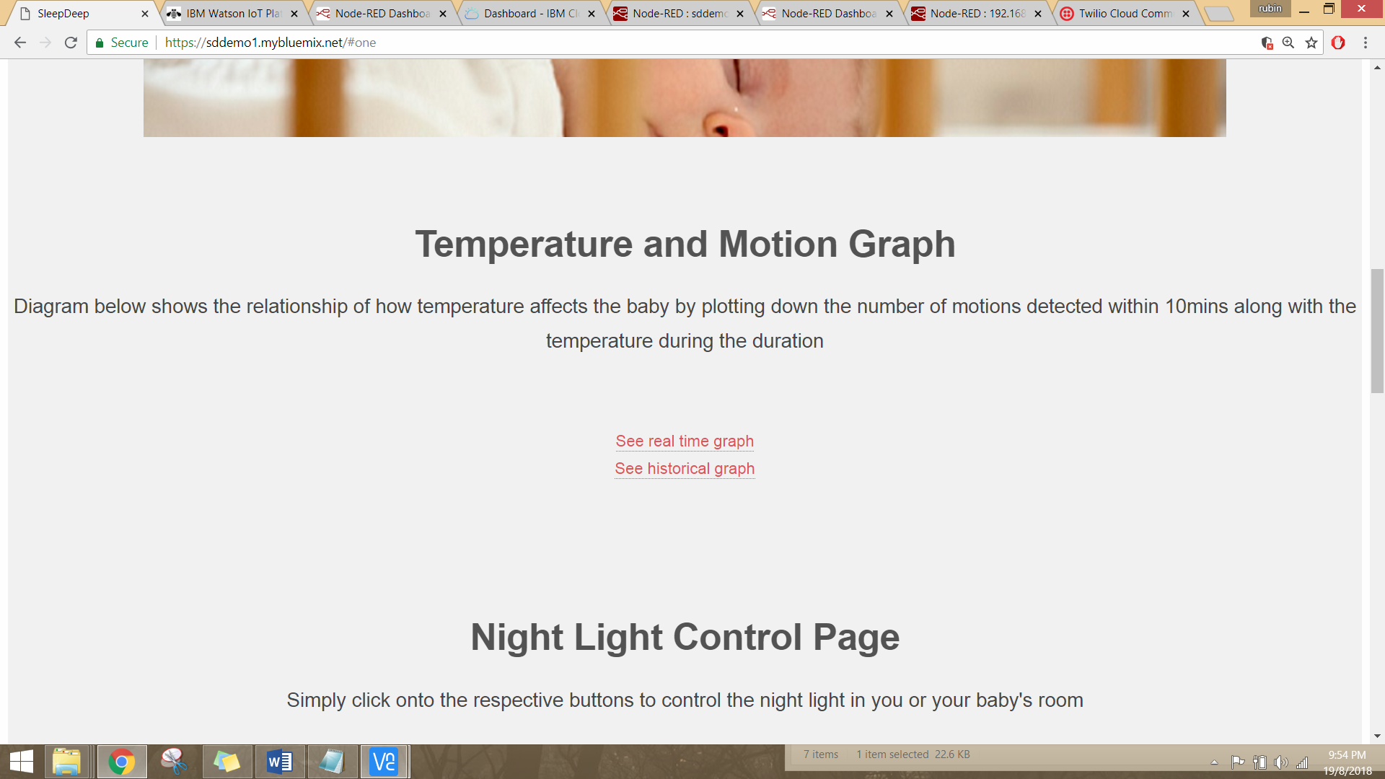

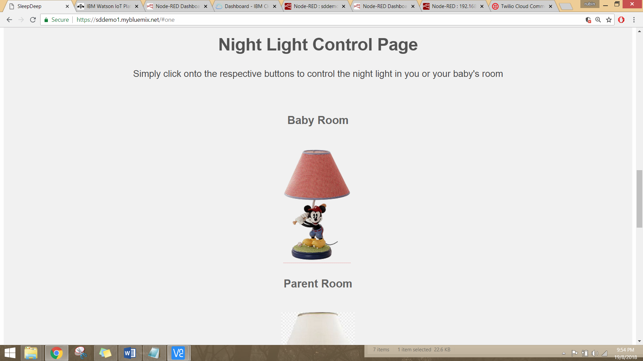

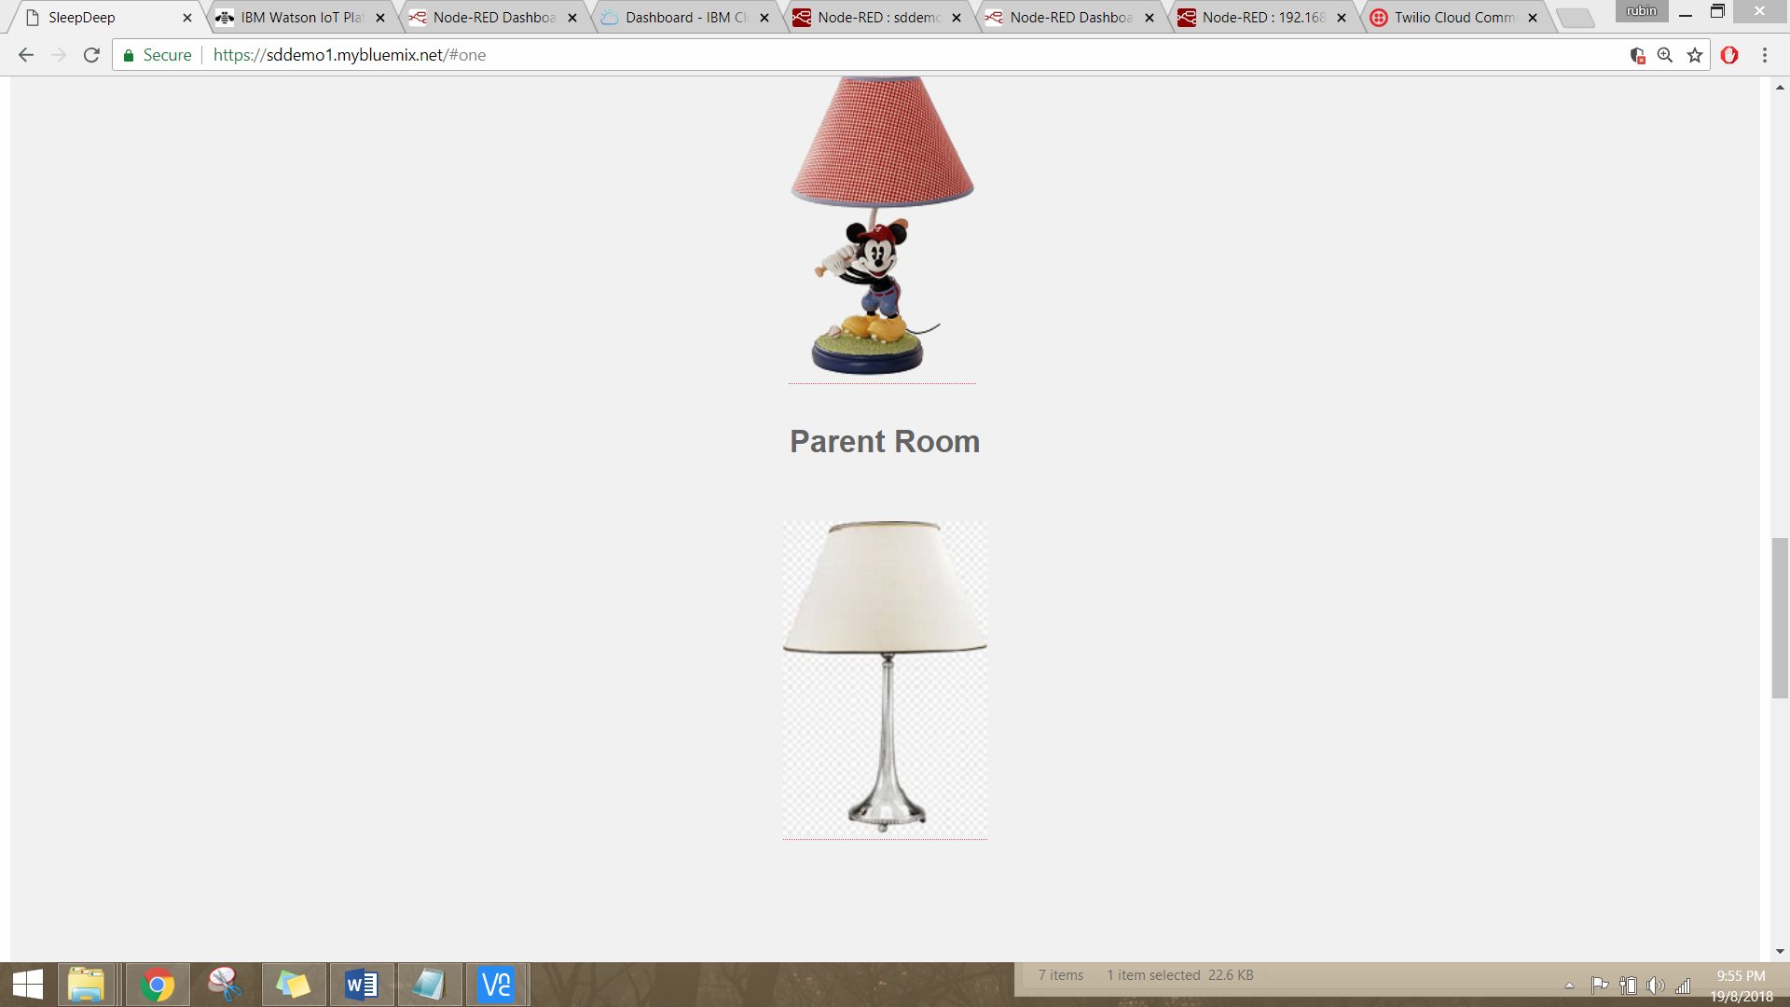

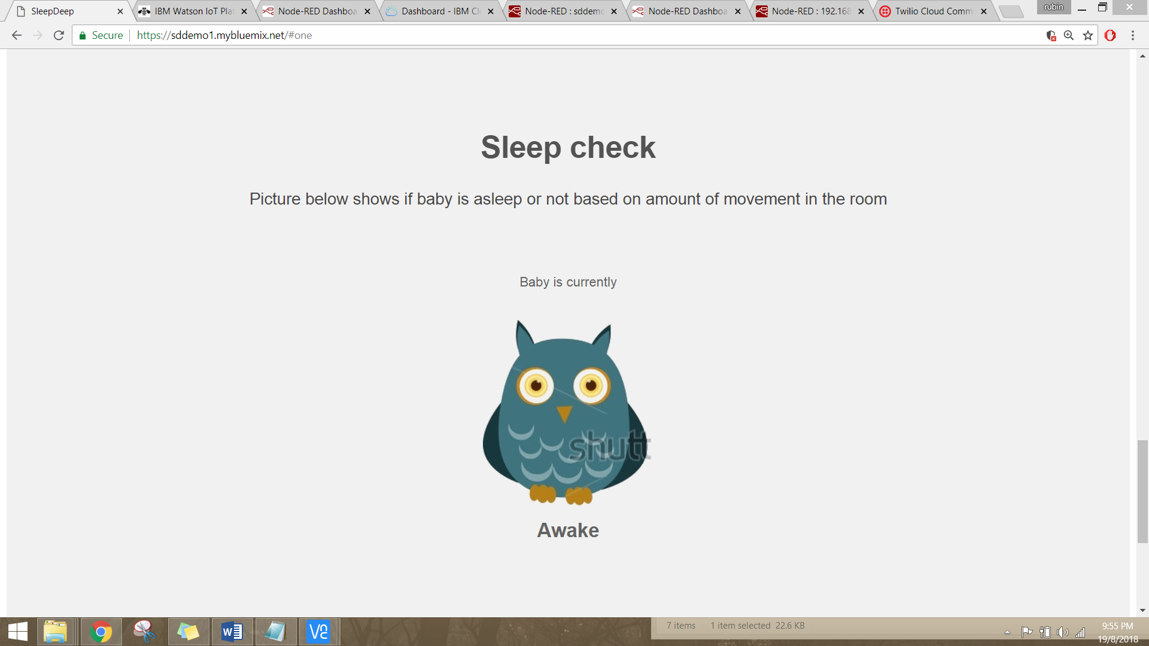

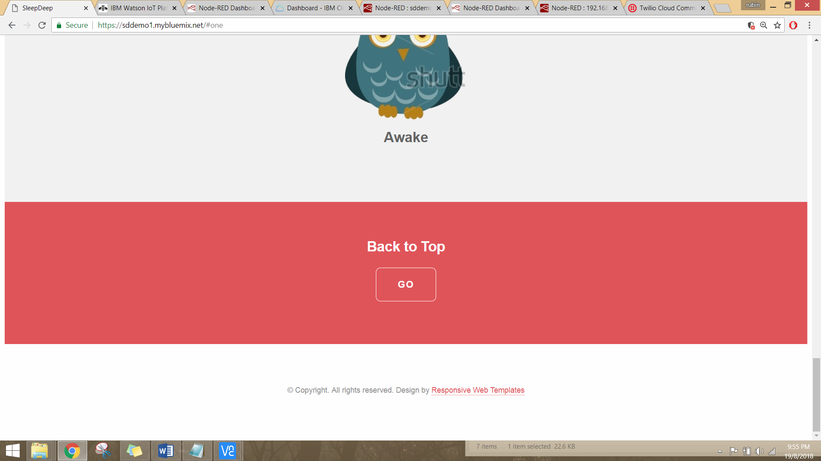

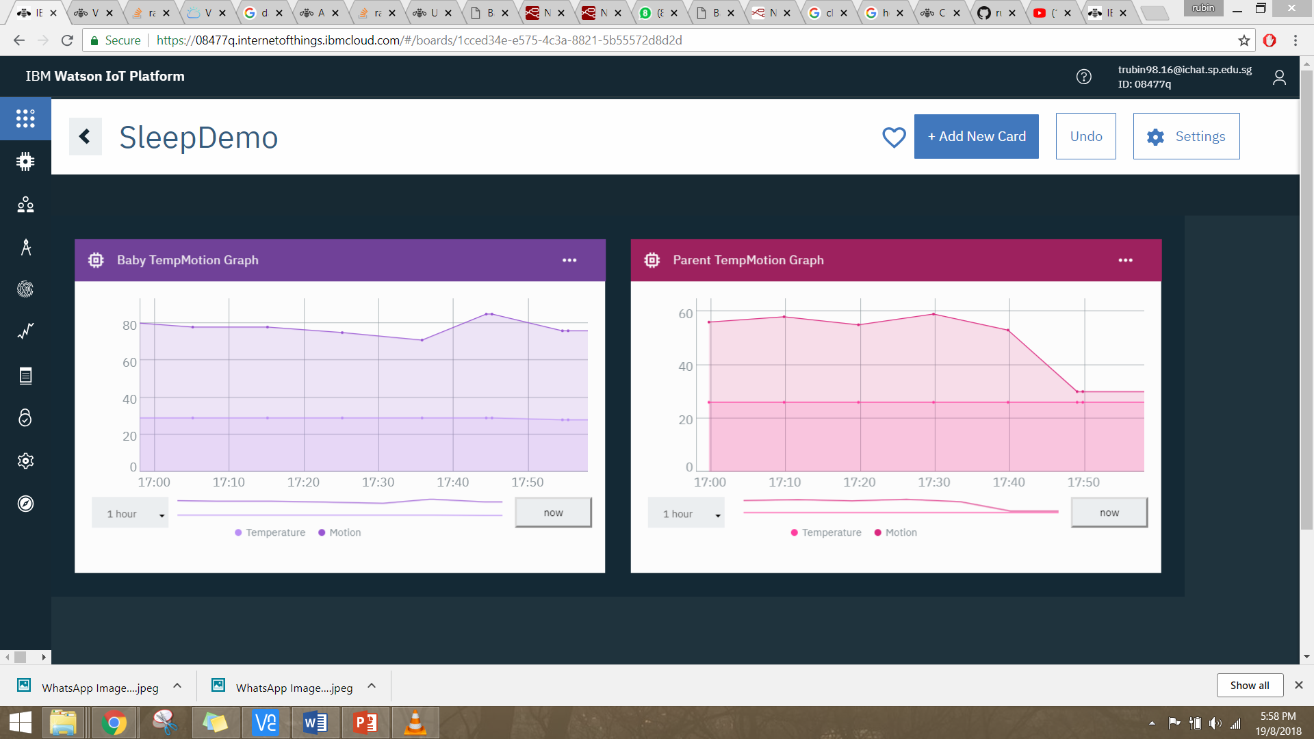

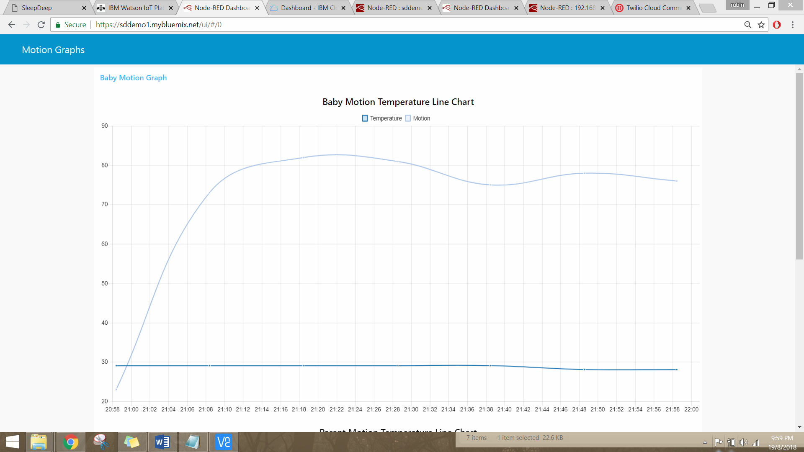

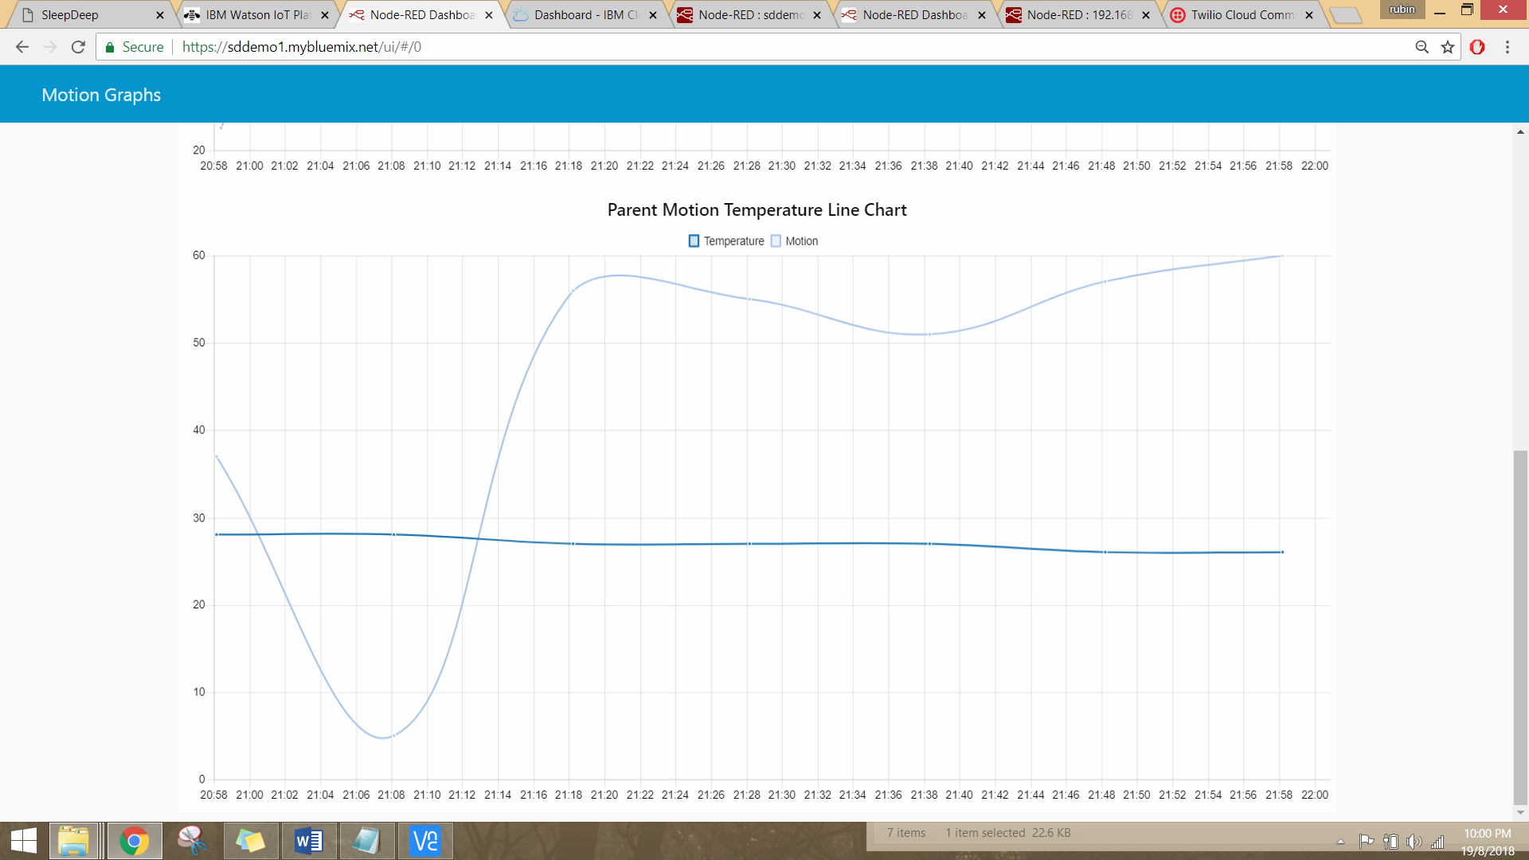

# Section 2 Hardware requirements

Hardware checklist

### LED

|  | Task | |
| --- | --- | --- |
|  | For this setup, the LED would be representing the baby’s night light in his/her room. It will later be used for parents to control the LED remotely from their room. | **LED** |

### Resistor for LED

|  | Task | |
| --- | --- | --- |
|  | * Resistors is required to connect LEDs to the GPIO pins of the Raspberry Pi to ensure small current flow. * This will ensure that the Raspberry Pi does not burn out or get damaged from the LED drawing more current |  |

### PIR Motion Sensor

|  | Task | |
| --- | --- | --- |
|  | The PIR sensor uses the pattern of infrared energy in its surroundings to detect when something nearby has moved. Hence, it will be used to detect the movement of the baby for this setup.  As for the sensitivity of the HC-SR501 PIR sensor, adjust both trimpot to the middle for optimal sensitivity and time before next trigger |  |

### DHT11 Temperature and Humidity Sensor

|  | Task | |
| --- | --- | --- |
|  | The DHT11 is able to capture humidity and temperature values using a capacitive humidity sensor and a thermistor to measure the surrounding air, and produces a digital signal on the data pin.  However for our setup we would only be using the temperature values ( would be done by the coding part ) since there is not much use of humidity values in a room environment. | **DHT11** |

### 10k Ω Resistor for DHT11 sensor

|  | Task | |
| --- | --- | --- |
|  | For the circuit work it requires the addition of “pull-up resistor” to the DATA line of the DHT11 sensor connected to the VCC line  For the circuit in addition of 10K ohms resistor is required  You can recognise a 10K ohms resistor by its color bands (brown:black:orange:gold) | **10K Ω RESISTOR**  **10K ohms resistor** |

# Section 3 Create IBM Iot App

## Setup Cloud Foundary and Bluemix IoT Service

In this section, you will learn how to create an IoT app IBM and the necessary services and toolchain. We assume that you have already created an IBM account beforehand.

Log in your Bluemix account and proceed to the IoT BoilerPlates Starter Page section

<https://console.bluemix.net/catalog/starters/internet-of-things-platform-starter>

|  | Task | |
| --- | --- | --- |
| a) | Choose your desired app name and leave the rest as default then click create |  |
| b) | Make sure your app has started before continuing. It might take 10 minutes so wait patiently. |  |
| c) | Under connections click iotf-service, click launch |  |
| d) | Select device type then click on add device type |  |
| e) | Select gateway and put your name, click next,click done,click next and your gateway should be created |  |
| f) | Click on browse, click add device |  |
| g) | Input your device type’s name you have created just now and give a device id you desire.        Click next until you see device security and type in the following as your auth token: AUTHTOKEN-*‘yourgwdeviceidname’,*click next,click done. |  |
| h) | Take down your **organization id, device type, device id, authentication token** |  |
| i) | Repeat the steps above for another device type named ‘led-SLEEPDEEP’ and another device ID named ‘ledid-SLEEPDEEP’ |  |

## Create toolchain

| No. | Task |
| --- | --- |
| a) | Go back to your dashboard and click on your cloud foundary app |
| b) | Scroll to the bottom and click enable for continious delivery |
| c) | Choose your toolchain name and git repository name of your choice then create an api key |
| d) | Click on Eclipse Orion Web IDE |
| e) | On the left navigation tab, under the ‘public’ folder, remove index.html. Then add the js folder and **add on the codes** **inside** **css and images folder** which can be found from the ‘Codes’ folder in github. therfore |
| f) | Afterwards, go into git |
| g) | Click on commit, you can write any message you want for the commit. |
| h) | Click on push and the codes will be uploaded |
| i) | After you have exited ‘Eclipse Orian Web IDE’ , restart the app |

# Section 4 Node-Red Bluemix

## Setup Node Red in IBM

| No. | Task |
| --- | --- |
| a) | Click on View app |
| b) | You will be redirected to node red page, click on ‘Go to your Node-Red flow editor’ |
| c) | You need to key your username and password to secure your node red |

## Adding additional Nodes for IBM

| No. | Task |
| --- | --- |
| a) | We will be installing additional nodes for the flow of our Node Red.  Click on the panel on the right hand side, then click on ‘manage palette’ |
| b) | Click on install tab in the search bar type in ‘ndoe-red-dashboard’ and you should see the following, then click on install. |
| c) | Repeat the steps above for the following nodes as well: |

## Create flow in IBM Node Red

| No. | Task |
| --- | --- |
| a) | In your Node Red, delete all flows that is inside. You can click onto any of the white space inside the flow, and hold CRTL-A to select all the nodes, then press on the delete button on your keyboard to remove all nodes. Alerternatively, you can also create another flow by clicking onto the plus sign. |
| b) | Import flow using the clipboard which can be found on the top right corner of the webpage. Paste the code found in the ‘Codes/Nodered\_codesforIBM.txt’ |
| c) | The flow should look similar to this |

## Configurating Twilio Node in IBM

Twilio node is to send messages to your phone to alert you the temperature is too high or low. Hence it has to be configured to send the message to your own phone number you desire.

| No. | Task |
| --- | --- |
| a) | Setup a new Twilio account at  [https://www.twilio.com/try-twilio](https://www.twilio.com/try-twilio ) and login to the console |
| b) | You will be asked to create a project when your account is first created.  Select Account Notifications |
| c) | In your Dashboard after the project is created, take note of the SID and Auth Token |
| d) | Go to ‘Developer Centre -> API Keys’ and click on ‘Create new API Key’ |
| e) | Take note of the details of SID and SECRET |
| f) | We will now get a Twilio phone number, go to ‘All Products & Services’ and choose ‘Phone Numbers’. Click on ‘Get Started’ then ‘Get your first Twilio phone number’. |
| g) | A random Twilio USA telephone number will be assigned to you, click on ‘Choose this number’. Take note of your phone number. |
| h) | As the USA based telephone number needs to send a SMS to the country we are in. Permission configuration is required for global SMS. It can be found in ‘Programmable SMS -> Settings -> Geo Permssions’. Add your country in Geographion Permissions. |
| i) | With all the credentials noted previously, go back to your node red and open the Twilio node. The phone number which you want the message to go to is put here. |
| j) | Click on ‘Add new twilio-api’ and write all the credentials noted previously here. |
| k) | Once deployed, the Twilio node is successfully set up! |

# Section 5 Raspberry Pi Node-Red

In this section, you will be configuring Node Red that is in your Raspberry Pi instead of IBM Bluemix. The values sent to Bluemix would be the temperature, motion values and controlling of lights with the use of Watson IoT. We will assume that Node-Red has been installed in your Raspberry Pi.

## Adding additional Nodes for in Raspberry Pi

| No. | Task |
| --- | --- |
| a) | We will be installing additional nodes for the flow of our Node Red.  Click on the panel on the right hand side, then click on ‘manage palette’ |
| b) | Click on install tab in the search bar type in ‘dht-sensor’ and you should see the following, then click on install. |
| c) | Repeat the steps above for the following nodes as well: |

## Created Node Red flow in Raspberry Pi

| No. | Task |
| --- | --- |
| a) | Open terminal window on your vnc view and start your node red by typing the command |
| b) | In your base pc browser, type in ‘*YourRaspberrypIPAddress*:*1880*’.  Example : http://192.168.1.10:1880/ |
| c) | Add a new flow to import the nodes |
| d) | Import flow using the clipboard which can be found on the top right corner of the webpage. Paste the code found in the ‘Codes/Nodered\_codesforRBP.txt’ |
| e) | Now we can start to build the flow to send data to our bluemix.  Here is what the flow will look like |

# Section 6 Cloudant Database

## Start up Historical Data Storage

For our cloud storage we are using cloudant to store the data from our raspberry pi to display a real time historical graph using IBM’s cards and boards.

| No. | Task |
| --- | --- |
| a) | Go to your organization IoT platform at ‘https://*orgid*.internetofthings.ibmcloud.com’ |
| b) | On the left navigation bar, click on Extensions. |
| c) | Click on ‘Setup’ for Historical Data Storage  select_historian_setup |
| d) | Select Cloudant NoSQL DB service to connect  select_cloudant |
| e) | Select ‘Day’ for bucket interval, your own time zone and database name can be left as default. |
| f) | You should get a confirmation message from a pop up, if not allow your browser to accept pop-ups then try again.  cloudant_authorization |
| g) | The data received by Watson Iot will be stored in the cloudantnosql DB |

## Data Visualization with Stored Data

We will be using boards and cards in the Watson IoT platform to display the line charts of parent and baby motion and temperature values.

| No. | Task |
| --- | --- |
| a) | From Watson IoT Platform navigation window, select ‘Boards’ and click on ‘Create New Board’  create_new_board1 |
| b) | Fill in the information about new board and click next. |
| c) | Add any members to access the card and click create  create_new_board_mems1 |
| d) | Click on the newly created board and select ‘Add New Card’ |
| e) | Select line chart under Devices |
| f) | Select the device that receive temperature and motion values, then click on next. |
| g) | Click on ‘Connect new data set’ and type in the following values |
| h) | Click on ‘Connect new data set’ and type in the following values. Then click on next. |
| i) | Select XL in settings for better visibility of data, then click next and done. |
| j) | Your line chart should be working now! |
| k) | The graph made was only for the baby room values. For parent room values, repeat the steps again, but at step g). property should have the value of ‘d.parenttemp’ and at step h) property should have the value of ‘d.parentmotion’. The final product should look like this. |

# Section 7 Task Allocation

## Individual tasks

Tan Ru Bin:

* Documentation
* IBM node-red flow
* Raspberry Pi node-red flow for parent
* Connect RPi node-red with IBM node-red via MQTT
* Web application HTML and CSS
* On and Off LED remotely from web application
* Display Graph
* Creation of cloudant storage

Chen Yan Jiun

* Documentation
* IBM node-red flow (Twilio)
* Raspberry Pi node-red flow for baby
* Data trigger for temperature
* Fritzing Diagram
* Youtube Video

Kennard Chua

* Testing

**-- End of CA2 Step-by-step tutorial --**